Software Engineering and Project Management
Module – 4
Introduction to Project Management

1 Why is Software Project Management I s Important?
More technically oriented students can be impatient at having to study something which keeps them away from their code. A lot of money is at stake with ICT projects. In the United Kingdom during the ﬁnancial year 2002–2003, the central government spent more on contracts for ICT projects than on contracts related to roads. Mismanagement of ICT projects means that there is less to spend on good things such as hospitals.
projects are not always successful. In a report published in 2003 Group in the United States analysed 13,522 projects and concluded that only a third of projects were successful; 82% of projects were late and 43% exceeded their budget.
The reason for these project shortcomings is often the management of projects. factors causing project failure identiﬁed ‘lack of skills and proven approach to project management and risk management’
2 What is a Project? Explain distinguish characteristics of projects
- The dictionary dentitions put a clear emphasis on the project being a planned activity. Planning is in essence thinking carefully about something before you do it . There is a hazy boundary between the non-routine project and the routine job.
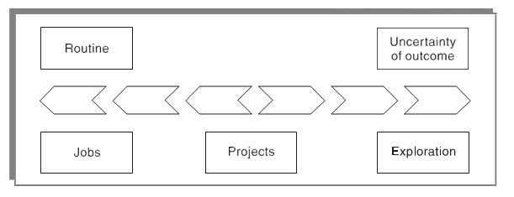
- non-routine tasks are involved;
- planning is required;
- septic objectives are to be met or a speciﬁed product is to be created;
- the project has a predetermined time span;
- work is carried out for someone other than yourself;
- work involves several specialisms;
- people are formed into a temporary work group to carry out the task;
- work is carried out in several phases;
- the resources that are available for use on the project are constrained;
- the project is large or complex.
- Compare Software Projects versus Other Types of Project.
Many techniques in general project management also apply to software project
management, identiﬁed some characteristics of software projects which make them particularly difficult.

Invisibility: When a physical artefact such as a bridge is constructed the progress can actually be seen. With software, progress is not immediately visible. Software project management can be seen as the process of making the invisible visible.

Complexity: Per dollar, pound or euro spent, software products contain more complexity than other engineered artefacts.
Conformity: The ‘traditional’ engineer usually works with physical systems and materials like cement and steel. These physical systems have complexity, but are governed by consistent physical laws. Software devel- opers have to conform to the requirements of human clients.

Flexibility: That software is easy to change is seen as a strength. However, where the software system inter- faces with a physical or organizational system, it is expected that the software will change to accommodate the other components rather than vice versa. Thus software systems are particularly subject to change.

4 Explain Activities Covered by Software Project Management
    - The feasibility study assesses whether a project is worth starting – that it has a valid business case. The stakeholders may know the aims they wish to pursue, but not be sure about the means of achievement. The developmental and operational costs, and the value of the beneﬁts of the new system, will also have to be estimated.
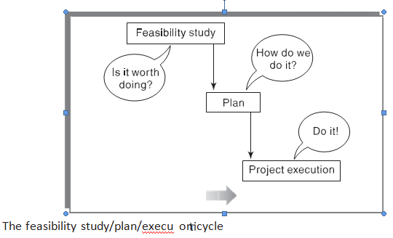

    - Planning If the feasibility study indicates that the prospective project appears viable, then project planning can start. For larger projects, we would not do all our detailed planning at the beginning. We create an outline plan for the whole project and a detailed one for the ﬁrst stage.
    - Project execution The project can now be executed. The execution of a project often contains design and implementation sub-phases.
Figure shows the typical sequence of software development activities recom- mended in the international standard ISO 12207. Some activities are concerned with the system while others relate to software. The development of software will be only one part of a project.
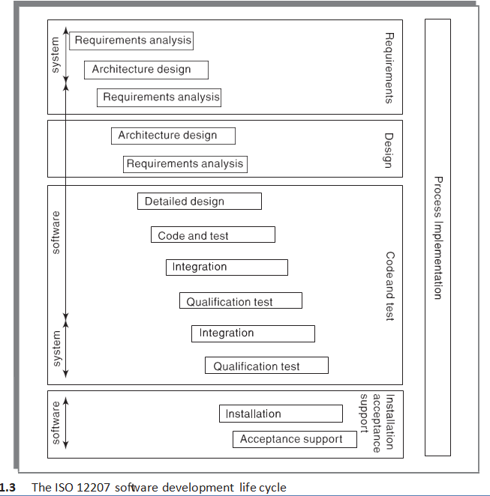

- Requirements analysis starts with requirements elicitation or requirements gathering which establishes what the potential users and their managers require of the new system. It could relate to a function – that the system should do something. It could be a quality requirement – how well the functions must work.

Architecture design The components of the new system that fulﬁl each requirement have to be identiﬁed. Existing components may be able to satisfy some requirements. In other cases, a new component will have to be made. These components are not only software: they could be new hardware or work processes.

- Detailed design Each software component is made up of a number of software units that can be separately coded and tested. The detailed design of these units is carried out separately.

- Code and test refers to writing code for each software unit. Initial testing to debug individual software units would be carried out at this stage.
- Integration The components are tested together to see if they meet the overall requirements. Integration could involve combining different software components, or combining and testing the software element of the system in conjunction with the hardware platforms and user interactions.
- Qualiﬁcation testing The system, including the software components, has to be tested carefully to ensure that all the requirements have been fulﬁlled.

- Installation This is the process of making the new system operational. It would include activities such as setting up standing data (for example, the details for employees in a payroll system), setting system parameters, installing the software onto the hardware platforms and user training.

Acceptance support This is the resolving of problems with the newly installed system, including the correction of any errors, and implementing agreed extensions and improvements.

5 Define Plans, Methods and Methodologies
Plan : A plan for an activity must be based on some idea of a method of work.
method : While a method relates to a type of activity in general, a plan takes that method (and perhaps others) and converts it to real activities, , identifying for each activity.
methodologies :The output from one method might be the input to another. Groups of methods or techniques are often grouped into methodologies such as object-oriented design.

6 Explain Deferent Ways of Categorizing Software Projects.

Compulsory versus voluntary users
In workplaces there are systems that staff have to use if they want to do something, such as recording a sale. However, use of a system is increasingly voluntary, as in the case of computer games. Here it is difficult to elicit precise requirements from potential users as we could with a business system.

Information systems versus embedded systems
A traditional distinction has been between information systems which enable staff to carry out ofﬁce processes and embedded systems which control machines. A stock control system would be an information system. An embedded, or process control, system might control the air conditioning equipment in a building.
Outsourced projects
While developing a large project, sometimes, it makes good commercial sense for a company to outsource some parts of its work to other companies. There can be several reasons behind such a decision. For example, a company may consider outsourcing as a good option, if it feels that it does not have sufficient expertise to develop some speciﬁc parts of the product. Indian software companies excel in executing outsourced software projects and have earned a ﬁne reputation in this ﬁeld all over the world.
Objective-driven development
Many software projects have two stages. First is an objective-driven project resulting in recommendations. This might identify the need for a new software system. The next stage is a project actually to create the software product.

7 Define stakeholders and List deferent stakeholders.
These are people who have a stake or interest in the project. Stakeholders can be categorized as:
- Internal to the project team This means that they will be under the direct managerial control of the project leader.
- External to the project team but within the same organization For example, the project leader might need the assistance of the users to carry out systems testing.
- External to both the project team and the organization External stakeholders may be customers (or users) who will beneﬁt from the system that the project implements.
8 Why setting objectives are important to success of the project.
- Among all these stakeholders are those who actually own the project.
- They control the ﬁnancing of the project.
- They also set the objectives of the project.
- the project objectives identify the shared intentions for the project.
- ‘customers can order our products online’ rather than ‘to build an e-commerce website’.
- authority is often a project steering committee responsibility for setting, monitoring and modifying objectives.
- The project manager runs the project on a day-to-day basis, but regularly reports to the steering committee

The mnemonic SMART is sometimes used to describe well-deﬁned objectives:
- Speciﬁc Effective objectives: Effective objectives are concrete and well deﬁned. Vague aspirations such as ‘to improve customer relations’ are unsatisfactory.

- Measurable : Ideally there should be measures of effectiveness which tell us how successful the project has been.

- Achievable : It must be within the power of the individual or group to achieve the objective.

- Relevant : The objective must be relevant to the true purpose of the project.

- Time constrained : There should be a deﬁned point in time by which the objective should have been achieved.

9 Explain Business Case
- A cost–beneﬁt analysis will often be part of the project’s feasibility study.
- The beneﬁts will be affected by the completion date:
- The quantiﬁcation of beneﬁts will often require the formulation of a business model which explains how the new application can generate the claimed beneﬁts.
- A simple example of a business model is that a new web-based application might allow customers from all over the world to order a ﬁrm’s products via the internet, increasing sales and thus increasing revenue and proﬁts.
Any project plan must ensure that the business case is kept intact. For example:
1 that development costs are not allowed to rise to a level which threatens to exceed the value of beneﬁts;
2 that the features of the system are not reduced to a level where the expected beneﬁts cannot be realized;
3 that the delivery date is not delayed so that there is an unacceptable loss of beneﬁts.

10 Write a shot Notes on Project Success and Failure
- The project plan should be designed to ensure project success by preserving the business case for the project.
- different stakeholders have different interests, some stakeholders in a project might see it as a success while others do not. The project objectives are the targets that the project team is expected to achieve.
- The project objectives are the targets that the project team is expected to achieve.
1 The agreed functionality
2 To the required level of quality
3 On time
4 Within budget.
A project could meet these targets but the application, once delivered could fail to meet the business case. A computer game could be delivered on time and within budget, but might then not sell. A commercial website used for online sales could be created successfully, but customers might not use it to buy products, because they could buy the goods more cheaply elsewhere.
We have seen that in business terms it can generally be said that a project is a success if the value of beneﬁts exceeds the costs.

11 What is Management? Explain different management activities.
Management, in general, involves setting objectives for a system and then monitoring the performance of the system.
management involves the following activities:
- planning – deciding what is to be done;
- organizing – making arrangements;
- stafﬁng – selecting the right people for the job etc.;
- directing – giving instructions;
- monitoring – checking on progress;
- controlling – taking action to remedy hold-ups;
- innovating – coming up with new solutions;
- representing – liaising with clients, users, developer, suppliers and other stakeholders.

Much of the project manager’s time is spent on only three of the eight identiﬁed activities, project planning, monitoring, and control.
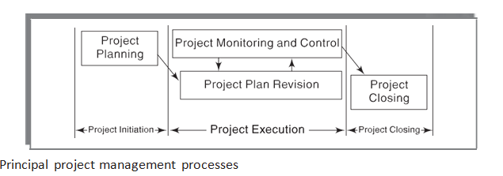
‘A Guide to the Project Management Body of Knowledge.’
- Estimation The following project attributes are estimated.
- Cost How much is it going to cost to complete the project?
- Duration How long is it going to take to complete the project?
- Effort How much effort would be necessary for completing the project?
- Scheduling Based on estimations of effort and duration, the schedules for manpower and other resources are developed.
- Stafﬁng Staff organization and stafﬁng plans are made.
- Risk Management This activity includes risk identiﬁcation, analysis, and abatement planning.
- Miscellaneous Plans This includes making several other plans such as quality assurance plan, conﬁgu- ration management plan, etc.

12 Explain Traditional versus Modern Project Management Practices
Over the last two decades, the basic approach taken by the software industry to develop software has undergone a radical change. Hardly any software is being developed from scratch any more. Software development projects are increasingly being based on either tailoring some existing product or reusing certain pre-built libraries. either case, two important goals of recent life cycle models are maximization of code reuse and compression of project durations.
Other goals include facilitating and accommodating client feedbacks and customer participation in project development work, and incremental delivery of the product with evolving functionalities.
Change requests from customers are encouraged, rather than circumvented. Clients on the other hand, are demanding further reductions in product delivery times and costs.
important differences between modern project management practices and traditional practices.
- Planning Incremental Delivery : Few decades ago, projects were much simpler and therefore more predictable than the present day projects. Now, projects are required to be completed over a much shorter duration, and rapid application development and deployment are considered key strategies.
- Quality Management : Of late, customer awareness about product quality has increased signiﬁcantly.
- Change Management (Change management is also known as conﬁguration management)

13 Explain Different phases of Project Management life cycle
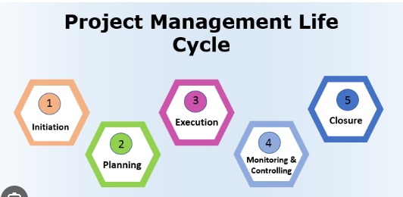

1. Project Initiation
- Conduct a feasibility study to identify the primary problem the project will solve and whether the project can deliver a solution to that problem
- Create a business case and define the project at a high level
- Create a Project Charter or project initiation document that outlines the vision, objectives and goals of the project
- Identify the high-level scope of the project and define the product or service the project will deliver
- Identify key project stakeholders
- Once the project gets a go-ahead, assemble the project team and establish a project office

2. Project Planning
- Create a Statement of Work document to flesh out the details of project deliverables
- Develop a Work Breakdown Structure
- Create a project plan, assign team members (and other resources) to the various tasks and build a detailed project timeline
- Identify the Project Team roles and other resources for the project. At this stage, the Project Manager – working with a project staffing function – will most likely identify specific people for some of the key roles needed for the success of the project.
- Create a risk mitigation plan to identify potential risks and develop a strategy to minimize them
- Incorporate an effective change management plan for necessary changes in the project and to avoid bottlenecks
- Create a communication plan to schedule interactions with relevant stakeholders

3. Project Execution
- Identify and assign the project team Assign the team and other resources to the project tasks and begin work in the planned manner
- Provide necessary guidance to the team on how tasks should be completed
- Monitor progress of the team
- Communicate with the stakeholders on a regular basis to ensure that the project deliverables are acceptable
- Tracking the progress of various project tasks
- Measure budget, timeline and quality performance of the project
- Conduct user reviews and collect feedback, and take any corrective actions needed
- Track all changes to the project scope (whether from team members or the stakeholders) and report on their impact to project goals.
- Monitor overall project performance, including all project plan changes, and ensure that all stakeholders and the project team are on the same page about the project status and its expected outcomes.

5. Project Closure
- Conduct a “End of Project” Review or Retrospective and to analyze project performance and a formal analysis of successes and failures
- Document project closure and provide reports to key stakeholders
- Account used/ unused budget and release remaining resources for other projects

